Program 1:

interface Myinterface {

public void method1();

public void method2();

}

class Demo implements Myinterface{

public void method1(){

System.out.println("implementation of method 1");

}

public void method2(){

System.out.println("implementation of method 2");

}

public static void main(String arg[]){

Myinterface obj=new Demo();

obj.method1();

obj.method2();

}

}

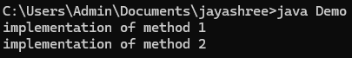

Program 2

interface Animal {

void sound();

void eat();

}

class Dog implements Animal{

public void sound(){

System.out.println("dog barks");

}

public void eat(){

System.out.println("dog eats bone");

}

}

public class Main{

public static void main(String args[]){

Animal mydog=new Dog();

mydog.sound();

mydog.eat();

}

}

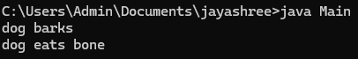

Program 3

interface Vehicle{

void start();

}

interface Car extends Vehicle {

void drive();

}

class Sedan implements Car {

public void start(){

System.out.println("sedan is starting");

}

public void drive(){

System.out.println("sedan is driving");

}

}

public class Main1{

public static void main(String args[]){

Car mycar=new Sedan();

mycar.start();

mycar.drive();

}

}



Program 4

interface Printable{

void print();

}

interface Showable {

void show();

}

class Document implements Printable,Showable {

public void print(){

System.out.println("printing document");

}

public void show(){

System.out.println("showing document");

}

}

public class Main2{

public static void main(String args[]){

Document doc=new Document();

doc.print();

doc.show();

}

}

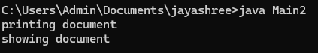

Program 5 (write all in same file and save in main file name)

interface Polygon {

default void getperimeter() {

System.out.println("Calculating the perimeter");

}

void getarea();

}

class Rectangle implements Polygon{

int l=5;

int b=10;

public void getarea(){

System.out.println("calcuating the area of rectangle : "+l\*b);

}

public void getperimeter() {

int l = 5;

int b = 10;

System.out.println("Calculating the perimeter of the rectangle: " + (2 \* (l + b)));

}

}

class Circle implements Polygon{

int r=5;

public void getarea(){

System.out.println("calcuating the area of circle: "+Math.PI \* r\*r);

}

public void getperimeter() {

int r = 5; // radius

System.out.println("Calculating the perimeter of the circle: " + (2 \* Math.PI \* r));

}

}

public class Test1{

public static void main (String args[]){

Polygon p1=new Rectangle();

p1.getarea();

p1.getperimeter();

Polygon c1=new Circle();

c1.getarea();

c1.getperimeter();

}

}

